Milestone Four

Results and Presentation

Michael Surdek
Southern New Hampshire University
DAT 650: Advanced Data Analytics
Professor Letia Sheldon
July 31, 2022
Results
Looking further into the results of the random forest model reveals that it can predict customers who will churn with an overall accuracy of approximately 59%. The confusion matrix shows that it can correctly predict 57% of customers who have churned and 60% of those who have not. These results means that the predictions from the model are significantly better than random guessing with no information, which would be expected to have a 50% accuracy. These are good results from a pilot study, and they confirm that there are signals in the data that are associated with customers who are likely to churn. For this reason, it is realistic that a fully developed model could predict customers who will churn with an accuracy in the range of 65-70%. Moving forward, a logistic regression model that uses more carefully chosen inputs and relies on a less black-box framework than a random forest, will not only improve predictive accuracy but also improve the ability to understand and quanitfy the factors that are causing GE to observe an increase in churn.
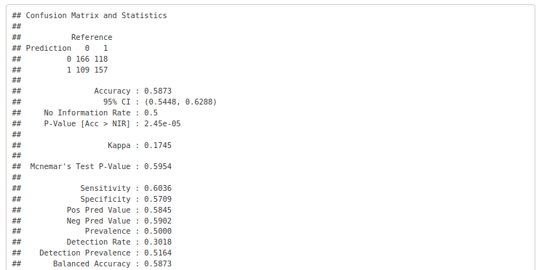
Another key output from the results of the model is variable importance, which is measured as the mean decrease in prediction accuracy from including each variable. This list shows the top 10 most important variables in the model, and these will be critical to improving the model further and understanding the true causes of customer churn.
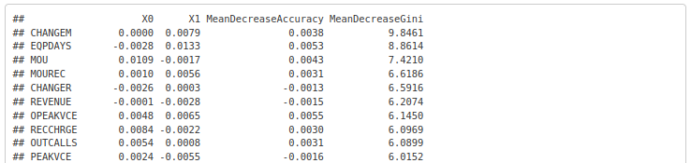
Full Implementation
The value that GE can gain from utilizing a model to predict customer churn depends on the evaluation of two separate hypotheses. The first is whether it is possible to predict customer churn based on cellular service, usage, and personal information and the second is whether contacting customers when they are deemed likely to churn will save some of them from cancelling. The results of this pilot study confirm that it is reasonable to accept the first hypothesis, as a minimally complex model can predict churn at a significantly better rate than random guessing. Full pursuit of this project should only improve these results. For simplicity’s sake, we will assume that 70% of the customers that the final model predicts to churn will be true positives who are in fact, likely to churn.
If GE has 1,000 customers, the model might identify 100 as likely to churn. When the model is evaluated on new customers, the results can be combined with the original data to identify the Customer ID and their estimated likelihood of churn.
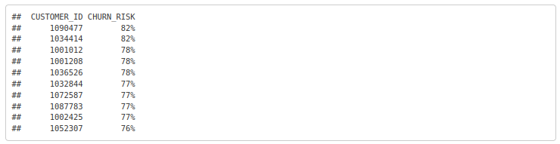
According to the model’s accuracy, 70 out of these 100 will actually churn. The question then becomes how many of the 70 can be prevented from cancelling if they are contacted with better offers or potential resolutions to their concerns. To estimate this, and to evaluate the second hypothesis, the 100 customers can be split into a test group that is contacted by customer service and a control group that is left alone. If the accuracy of the model is as we expect, 35 of 50 customers from the control group will churn. For the test group, the difference between 35 and the number of actual cancellations that they observe is half the amount of customers per 1,000 that can be expected to be saved by proactive outreach based on the predictive model. For example, if there are only 25 cancellations in the control group, then it makes sense to say that they could have saved 20 customers out of the 1,000 originally sampled and the 100 who were identified as likely to churn. Based on an average montly revenue from the data of approximately $58, preventing 20 cancellations would save $1,160 of recurring monthly revenue per 1,000 customers.
If GE has 50,000 active subscribers to their service, undertaking full implementation of this project can result in saving $58,000 of monthly revenue. This estimate depends on the size of GE’s subscriber base (50,000), the accuracy of the model (70%), the proportion of customers that it predicts as likely to churn (10%), and the percent of those that can be saved by proactive outreach (28%). If any of these factors turn out better than what seems most probable at this time, GE will only realize more value from this approach.

